Test Case: tc002_SPX_Dev5_Crear_Requisicion_Spot_Con_FAD_Tipo_Cobro_CC
Step 1 - Enter username and password and click to button Enter : Credentials Entered
Image file-name: QC_Testing-tc002_SPX_Dev5_Crear_Requisicion_Spot_Con_FAD_Tipo_Cobro_CC-1790177157936

Step 2 - Select to UEN and Access to Spot Buy Requisitions : UEN Correctly selected and Correct access
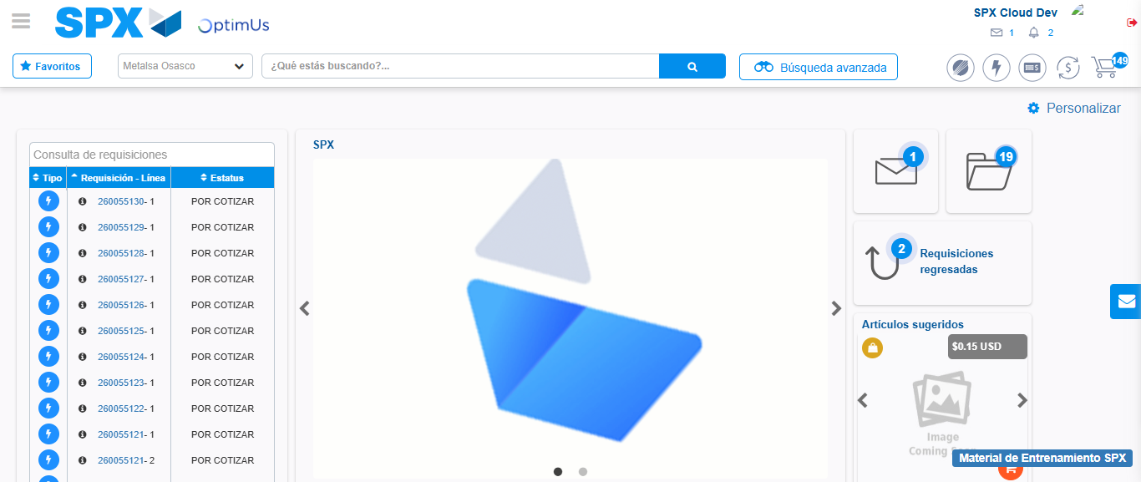Image file-name: QC_Testing-tc002_SPX_Dev5_Crear_Requisicion_Spot_Con_FAD_Tipo_Cobro_CC-1790177181889

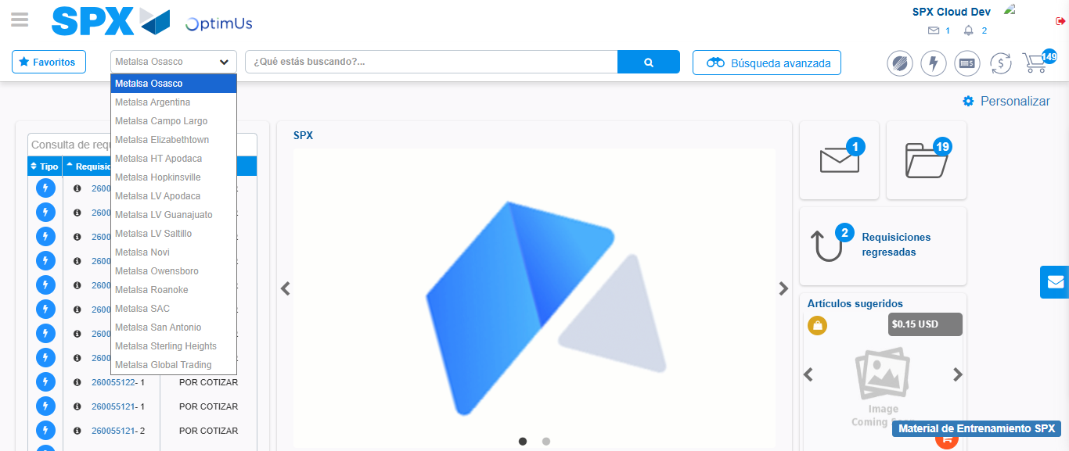Image file-name: QC_Testing-tc002_SPX_Dev5_Crear_Requisicion_Spot_Con_FAD_Tipo_Cobro_CC-1790177182538

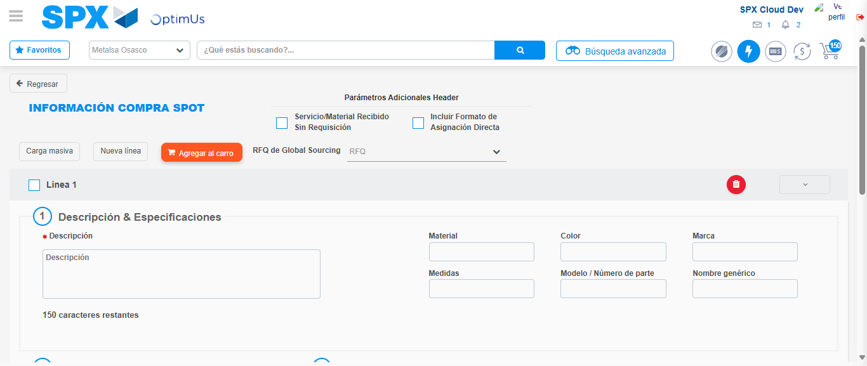Image file-name: QC_Testing-tc002_SPX_Dev5_Crear_Requisicion_Spot_Con_FAD_Tipo_Cobro_CC-1790177188556

Step 3 - Add FAD to Requisition: FAD Successfully Added
Image file-name: QC_Testing-tc002_SPX_Dev5_Crear_Requisicion_Spot_Con_FAD_Tipo_Cobro_CC-1790177188812

Image file-name: QC_Testing-tc002_SPX_Dev5_Crear_Requisicion_Spot_Con_FAD_Tipo_Cobro_CC-1790177189059

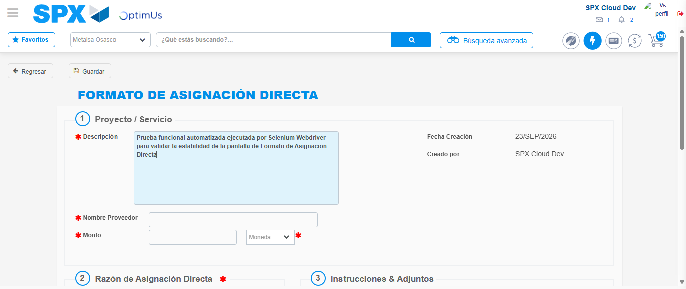Image file-name: QC_Testing-tc002_SPX_Dev5_Crear_Requisicion_Spot_Con_FAD_Tipo_Cobro_CC-1790177191966

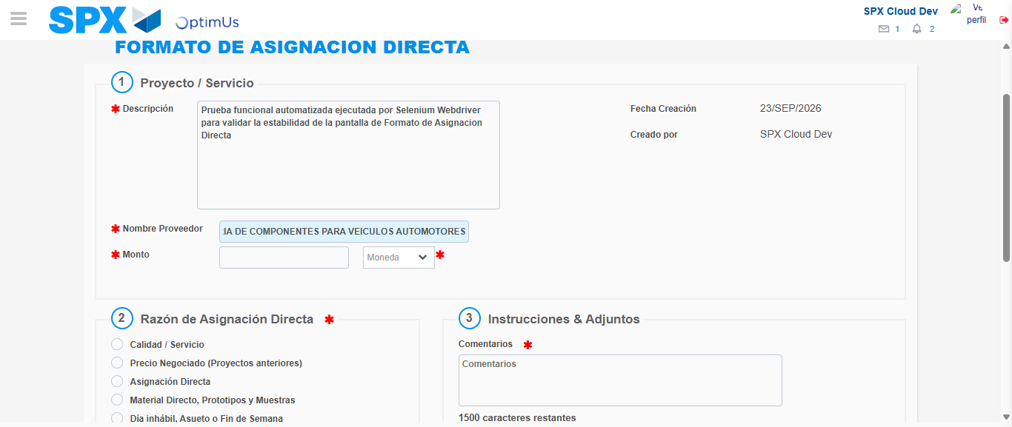Image file-name: QC_Testing-tc002_SPX_Dev5_Crear_Requisicion_Spot_Con_FAD_Tipo_Cobro_CC-1790177202638

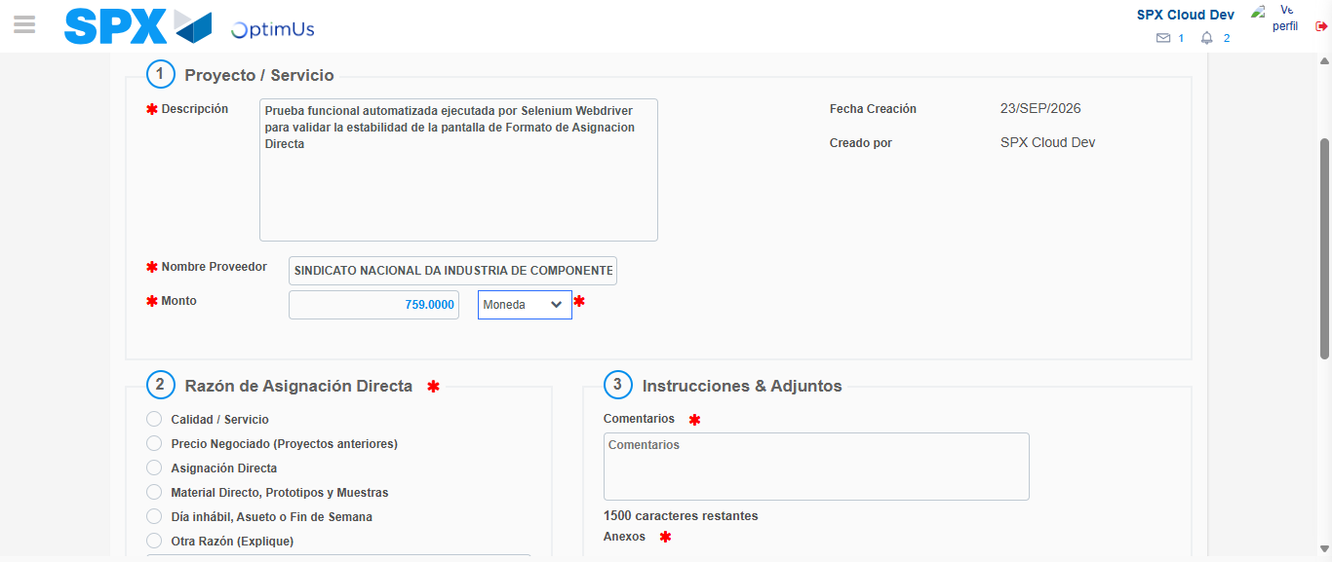Image file-name: QC_Testing-tc002_SPX_Dev5_Crear_Requisicion_Spot_Con_FAD_Tipo_Cobro_CC-1790177203078

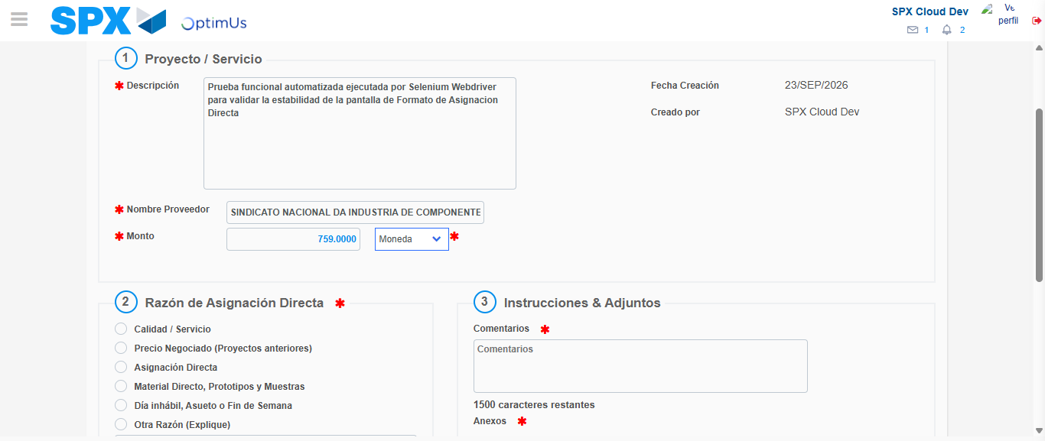Image file-name: QC_Testing-tc002_SPX_Dev5_Crear_Requisicion_Spot_Con_FAD_Tipo_Cobro_CC-1790177203269

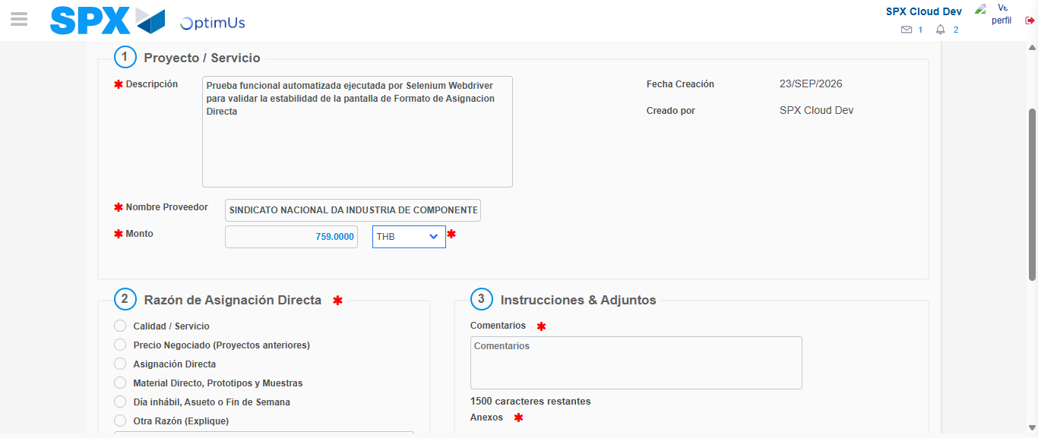Image file-name: QC_Testing-tc002_SPX_Dev5_Crear_Requisicion_Spot_Con_FAD_Tipo_Cobro_CC-1790177203663

Image file-name: QC_Testing-tc002_SPX_Dev5_Crear_Requisicion_Spot_Con_FAD_Tipo_Cobro_CC-1790177203879

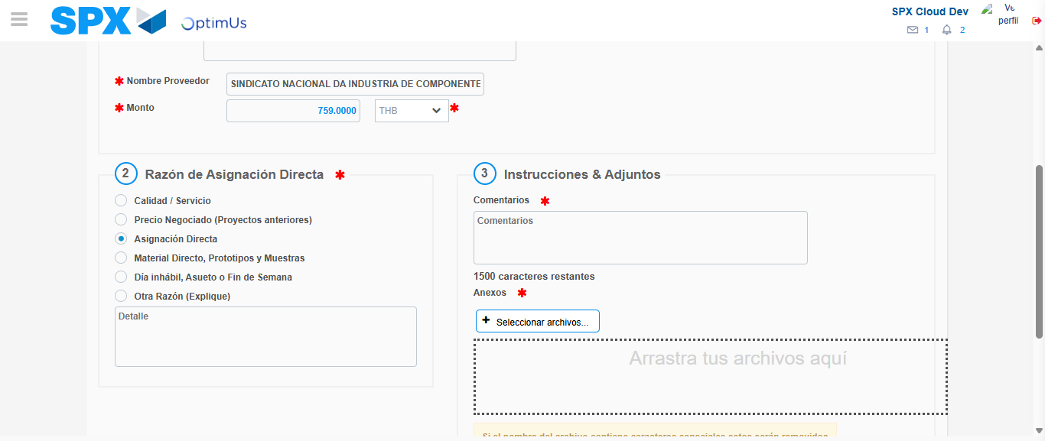Image file-name: QC_Testing-tc002_SPX_Dev5_Crear_Requisicion_Spot_Con_FAD_Tipo_Cobro_CC-1790177204690

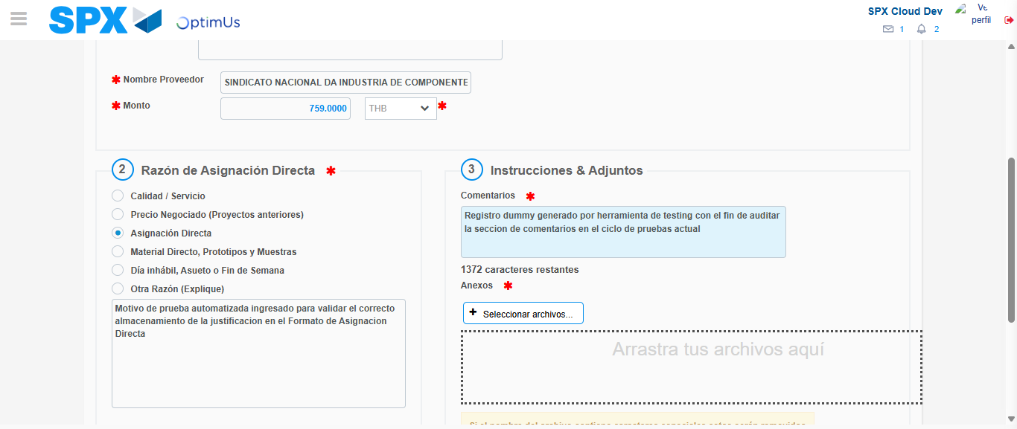Image file-name: QC_Testing-tc002_SPX_Dev5_Crear_Requisicion_Spot_Con_FAD_Tipo_Cobro_CC-1790177215725

Image file-name: QC_Testing-tc002_SPX_Dev5_Crear_Requisicion_Spot_Con_FAD_Tipo_Cobro_CC-1790177216669

Step 4 - Data Capture Spot Buy Requisition: Data captured correctly
Image file-name: QC_Testing-tc002_SPX_Dev5_Crear_Requisicion_Spot_Con_FAD_Tipo_Cobro_CC-1790177188812

Image file-name: QC_Testing-tc002_SPX_Dev5_Crear_Requisicion_Spot_Con_FAD_Tipo_Cobro_CC-1790177189059

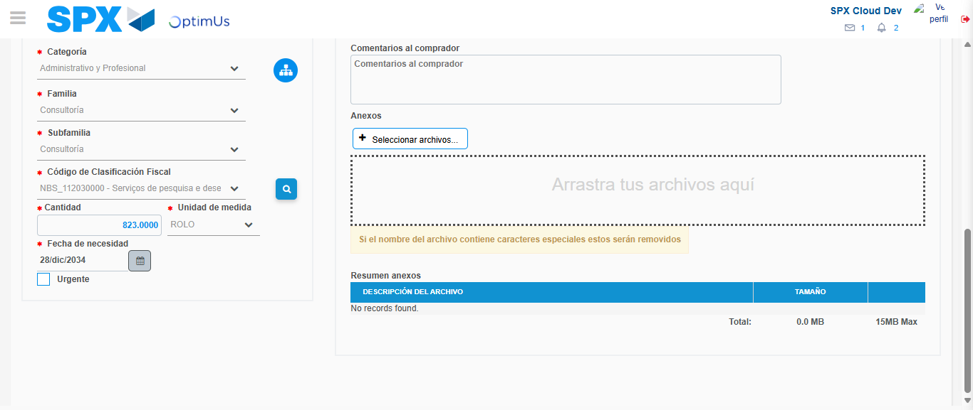Image file-name: QC_Testing-tc002_SPX_Dev5_Crear_Requisicion_Spot_Con_FAD_Tipo_Cobro_CC-1790177235166

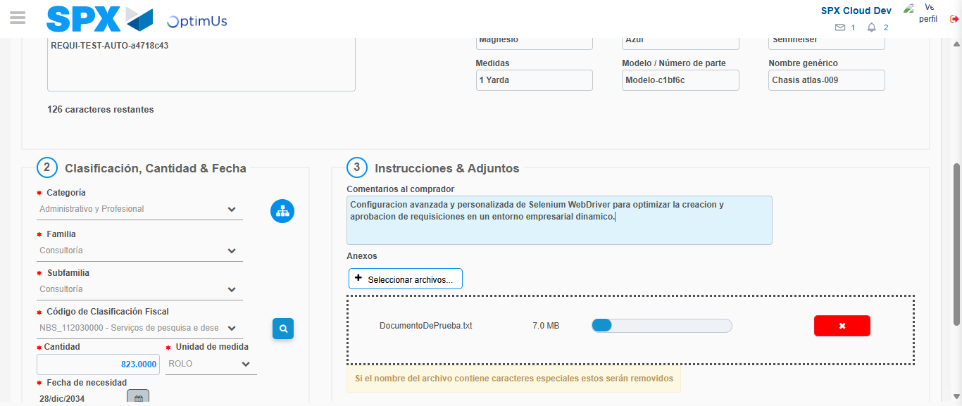Image file-name: QC_Testing-tc002_SPX_Dev5_Crear_Requisicion_Spot_Con_FAD_Tipo_Cobro_CC-1790177236226

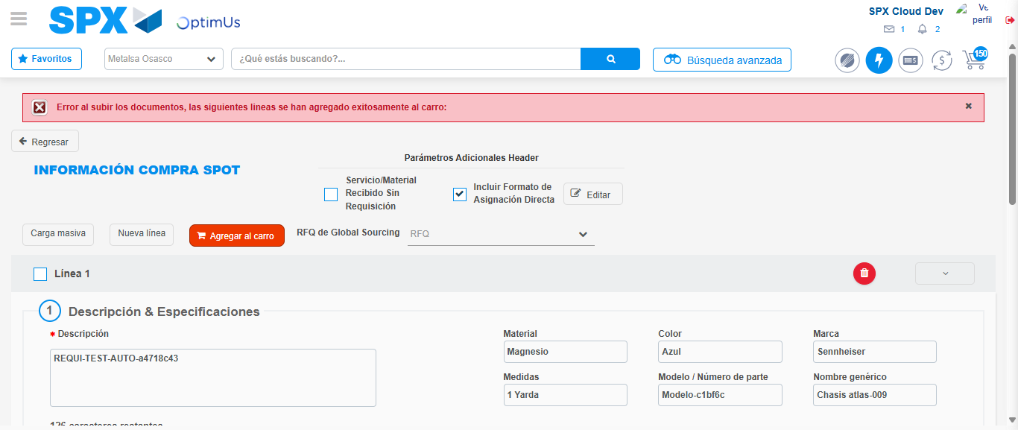Image file-name: QC_Testing-tc002_SPX_Dev5_Crear_Requisicion_Spot_Con_FAD_Tipo_Cobro_CC-1790177255684

Step 8 - Return to Main Page SPX : Return to Main Page SPX
Image file-name: QC_Testing-tc002_SPX_Dev5_Crear_Requisicion_Spot_Con_FAD_Tipo_Cobro_CC-1790177181889

Image file-name: QC_Testing-tc002_SPX_Dev5_Crear_Requisicion_Spot_Con_FAD_Tipo_Cobro_CC-1790177182538

Image file-name: QC_Testing-tc002_SPX_Dev5_Crear_Requisicion_Spot_Con_FAD_Tipo_Cobro_CC-1790177188556

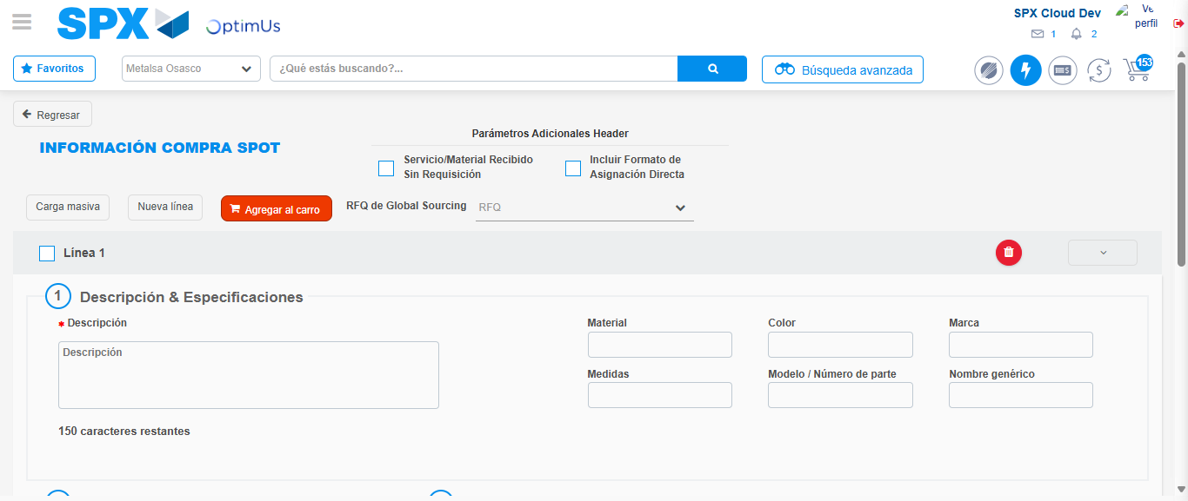Image file-name: QC_Testing-tc002_SPX_Dev5_Crear_Requisicion_Spot_Con_FAD_Tipo_Cobro_CC-1790177275575

Image file-name: QC_Testing-tc002_SPX_Dev5_Crear_Requisicion_Spot_Con_FAD_Tipo_Cobro_CC-1790177275732

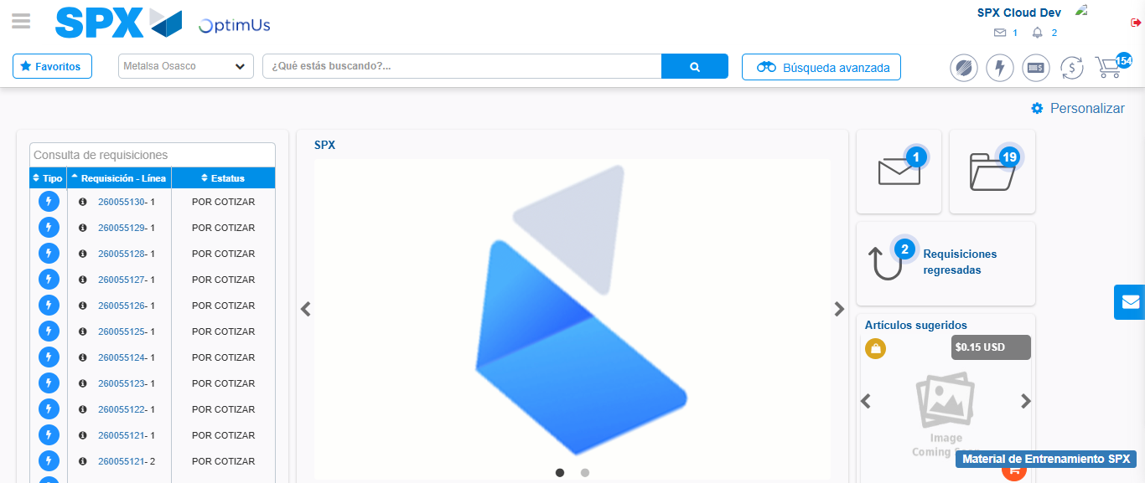Image file-name: QC_Testing-tc002_SPX_Dev5_Crear_Requisicion_Spot_Con_FAD_Tipo_Cobro_CC-1790177297045

Step 9 - Log Out : Log Out SPX
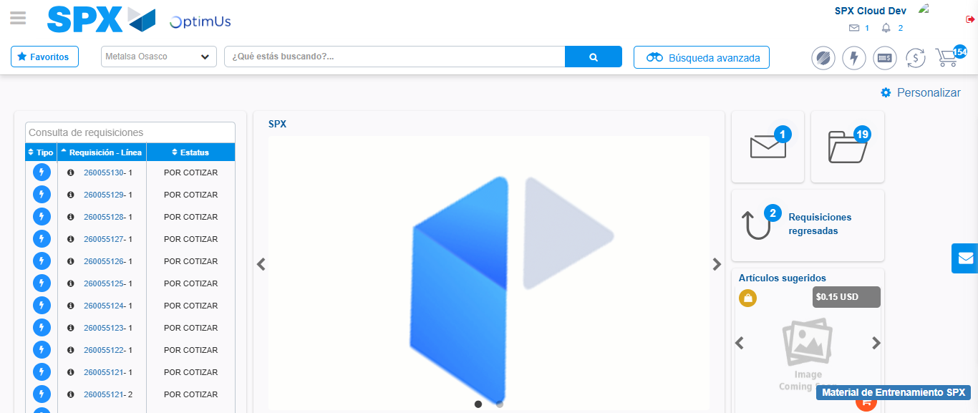Image file-name: QC_Testing-tc002_SPX_Dev5_Crear_Requisicion_Spot_Con_FAD_Tipo_Cobro_CC-1790177297395

